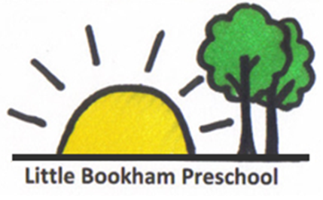

Animals Policy

When registering at the Preschool parents/carers are asked to provide information of any allergies that their child may have.

All staff will be made aware of any allergies, and these will be taken into account when planning activities involving animals.
If the Preschool has arranged for any animals to visit the Preschool as part of a planned activity Parents/carers will be informed in advance via the weekly email.

We will then send out consent forms to parents/carers to gain their permission for their children to handle the animals at the Preschool.
Animals will not be allowed near food, dishes, worktops or food preparation areas. Children should wash their hands with soap and water after handling animals

Checklist for visits to farms
- A site visit must be made by a member of the staff team before an outing to a farm can be arranged. We will check that the farm is well managed, that the grounds and public areas are as clean as possible, and that suitable First Aid arrangements are made. Animals should be prohibited from any outdoor picnic areas.
- Check that the farm has suitable washing facilities, appropriately signposted, with running water, soap and disposable towels or hot air hand dryers. Any portable water taps should be appropriately designed in a suitable area.
- We will ensure that there is an adequate number of adults to supervise the children,
taking into account the age and stage of development of the children.
- We will ensure suitable precautions are in place where appropriate e.g. in restricted
areas such as near slurry pits or where animals are isolated.
- If children are in contact with, or feeding animals, we will warn them not to place their faces against the animals or put their hands in their own mouths afterwards, and explain why.
- After contact with animals and particularly before eating and drinking, we will ensure that all children wash and dry their hands thoroughly. If young children are in the group, hand washing will need to be supervised. Always explain why the children need to do this.
- Meals, breaks or snacks will be taken well away from the areas where
animals are kept and children should be warned not to eat anything which has
fallen on the ground. Any crops produced on the farm should be thoroughly
washed in portable water before consumption.
- Ensure children do not consume unpasteurised produce, e.g. milk or cheese, or taste animal foodstuffs, such as silage and concentrates.
- Manure or slurry presents a particular risk of infection and children should be
warned against touching it. If they do touch it, we will ensure that they thoroughly wash and dry their hands immediately.
- We will ensure all children wash their hands thoroughly before departure.
- We will ensure footwear is as free as possible from faecal materials.

